SMALL GRANTS PROGRAM (SGP)

Tumen River Green Pilgrimage REPORT

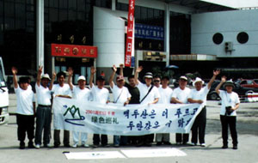
From June 18-24, Green Korea United and Green Yanbian had a Green Pilgrimage program at Tumen River as an environmental SGP (Small Grant Program) sponsored by Tumnennet. We followed the river and walked from Kaishantun to Changbai mountain. The pilgrimage's main focus was to monitor the Tumen river environmental situations, and raise environmental awareness both in the local region, and throughout South Korea.

Through this Green Pilgrimage we found that the pollution causes significant economic loss to the people and breaks the harmony of their lives. This is the report about the Tumen River green pilgrimage. There are five ways in which environmental pollution affects the people around Tumen River.

- Industry
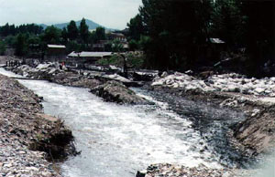
The Kaishantun pulp mill has been spending a great deal of money to purify water for industrial use. The polluted water degraded the quality of the pulp, and as a result caused economic loss. Ironically, the pulp mill is one of the main industrial pollutant producers as well as pollution sufferers around Tumen River. However, when we talk about the Kaishantun pulp mill we should also consider the workers as victims of environmental pollution. Thus we need to consider both the environment as well as economics.
Baigin is another example. There is hydro power plant where almost all electricity produced is exported to the DPRK (Democratic People's Republic of Korea). As a result of sediment and mineral separation waste water at the large Musan iron mine, the Baizin power plant must change their turbine once per year while other power plants in China change their turbines once every eight years. It costs the Baizin plant 100,000 yuan (16,000,000 won.) per year. The plant sells the electricity to North Korea, but the benefit of electricity production decreased because of pollutants from North Korea

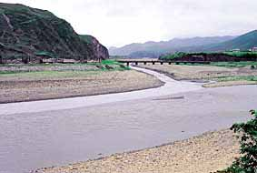
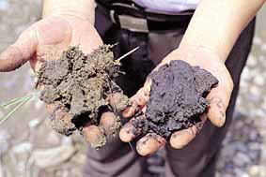
2. Agriculture
Villagers along the Tumen River are using its water for agricultural purposes. Unfortunately, the water contains sediment and mineral separation waste water from the Musan iron mine, which affects the productivity of rice and other crops. Specifically, the sediment makes the soil hard and the roots not grow well. Farmers spend a lot of time and energy digging out the sediment from their rice fields.

3. Fishery
The old people we met during the pilgrimage told us that there used to be many fishermen in Tumen River, but nowadays they are hard to find. Before migratory fish such as salmon and wolfish were caught in the upper reaches of the river, but now they are only caught in the lower reaches of the river.
Until 1973, shells could be found in the river in Baizin. According to the local people's expression, "shells are as many as stones in river," but because of the Musan iron mine pollution beginning in 1973, no more shells can be found.

4. Drinking Water
During the pilgrimage it was hard to find communities along the river that have been able to drink the river water, especially during the period of low water flow.

5. Public health
The first day of the pilgrimage we started from Kaishantun. In that city we found the smell of the city to be quite serious because of the Kaishantun chemical pulp mill. We asked the local people, but they did not recognize the smell, which means that they are already accustomed to it. Such air pollution will affect the people's health.
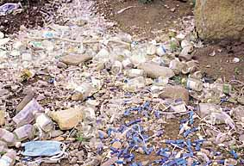
People around Tumen River still eat fish caught in its waters. They talked about the common morphological changes they saw in certain parts of the fishes' bodies.
They asked us if it was safe to eat fish caught in the Tumen River and then stated that a cow ate a rice straw grown from the Tumen River water (which included sedimentation from Musan iron mine) and now has liver dysfunction. There is a need for further scientific research, but it is certain that the villagers fear the polluted Tumen River. They believe the polluted water affects their health. Through this Green Pilgrimage we found out that the pollution of the Tumen River directly destroyed the ecosystem and biodiversity, in addition to affecting people's lives. We need to consider the people who suffer from the pollution of the Tumen River.

The border of Russia, China and North Korea
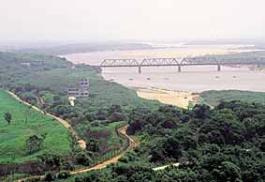Large amounts of pollutants discharged into the Tumen River watershed came from China's two large-scale pulp mills at Kaishantun and Shixian, and from the DPRK's Musan iron mine. Up till now there have been many reports about the pollution of the Tumen River. So, we know the problem and how to remove it-- we just need to find the way and carry it out. In order to do this, we need to strengthen regional cooperation as well as assistance from intergovernmental organizations such as UNDP (United Nations Development Program), UNESCO (United Nations Educational, Scientific, and Cultural Organization), and international NGOs. We cannot forget one old man's comment during our pilgrimage:
"Can I see a clean Tumen River before I die?"

